CONFIGURE SSH ON ROUTER R2
Before configuration,
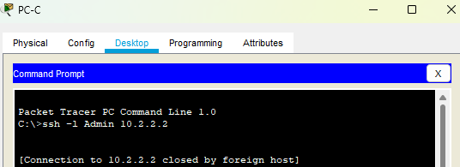
Step 1: Configure a domain name. Configure a domain name of jsm.com on R2.
R2(config)# ip domain-name jsm.com
Step 2: Configure users for login to the SSH server on R2. Create a user ID of Admin with the highest possible privilege level and a secret password of abc123.
R2(config)# username Admin privilege 15 secret abc123
Step 3: Configure the incoming vty lines on R2. Use the local user accounts for mandatory login and validation. Accept only SSH connections.
R2(config)# line vty 0 4
R2(config-line)# login local
R2(config-line)# transport input ssh
Step 4: Generate the RSA encryption key pair for R2. The router uses the RSA key pair for authentication and encryption of transmitted SSH data. Configure the RSA keys with a modulus of 1024. The default is 512, and the range is from 360 to 2048.
R2(config)# crypto key generate rsa
The name for the keys will be: R2.jsm.com Choose the size of the key modulus in the range of 360 to 2048 for your General Purpose Keys. Choosing a key modulus greater than 512 may take a few minutes. How many bits in the modulus [512]: 1024
% Generating 1024 bit RSA keys, keys will be non-exportable...[OK]
Step 5: Verify the SSH configuration. Access R2 using SSH.
a. From the PC-C command prompt, SSH to the S0/0/1 interface on R2 at 10.2.2.2. Use the username Admin and password Adminpa55 to log in.
PC> ssh -l Admin 10.2.2.2
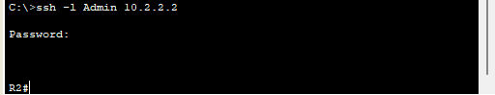
b. Exit the SSH session.

